 | CFAS Enterprises Inc.  After Market Utility Power Equipment Brokerage  Mailto:Staff@CFASPower.com  Turbine URL: http://CFASPower.com/Index.html  Reciprocating URL: http://CFASPower.com/Recips.html
GTG_1675RC_Fm FS3002_50Hz.doc

GE Fm 3-3002J Thomassen Package 10100KW 10500V 50Hz NG Generator Package

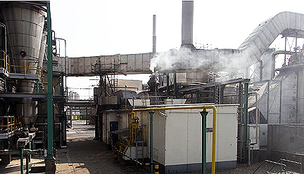
Asking Price: Euros 650,000
POWER GENERATION PACKAGE
TURBINE
Manufacturer/Packager: Thomassen
Turbine Type: FS3002J
Date of Installation: 1981
Power Rating ISO: 10.1 MW
Fuel configuration: Natural Gas
Exhaust Gas Flow: 180,000 kg/hr @530 Deg C
Mounting: Skid
Acoustic Enclosure: Yes
Start System: Electric Motor (200 kw)
Total Starts: 1880
Date of last Major Overhaul: 2005
Hours Since Last Overhaul 45,000
Hot Gas Path Inspection: 2008
Date of last Borescope Inspection: 2010
Maintenance History: Regular Maintenance
OEM Manuals: Available
Major Spares Available Nozzle Ring (value-120k Euros)+ other items
Main Gearbox (Spare Unit also Available)
Manufacturer: Voith
Power: 14,000 kw
Model: AD 63 USO
Date of Last Inspection 2008
RPM: 6519 - 1500
ALTERNATOR
Manufacturer: Holec
Date of Manufacture: 1981
Model: DG 150/145/95
RPM: 1500
Hertz: 50
Insulation Class: F
Volts: 10,500
Balance of Plant
Turbine Control System: Speedtronic Mk II
Air Intake Filtration System : Yes
Oil Cooler : Yes
Exhaust System : Yes, available to first flange of ducting
Gas Press Reducing Station : Available
Inspection December 2010
Date Plant Last Run 2011
Major Spares Included
Excellent Working Condition

